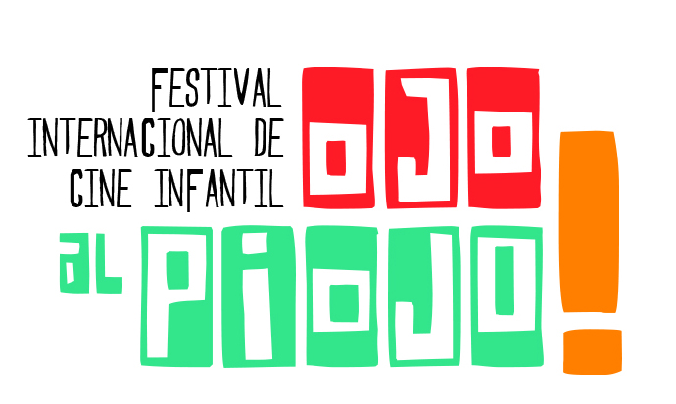

Ojo al piojo
The 7th International Children’s Film Festival
from 10 to 15 of july

The Centro Audiovisual Rosario (Rosario Audiovisual Center), under the Ministry of Culture and Education of the Municipality of Rosario invites directors, producers, children, youngsters, adults, students of film workshops, schools, to show their short films on a screen that brings together films from around the world that excite, entertain, teach and invite to live a special moment.

This Festival proposes a meeting place between the cinema and the children who assume a leading role, as they participate as filmmakers, jury members and spectators.

The innovation of the audiovisual language, the quality productions and the respect for the children's public are the fundamental axes that the Festival proposes for the promotion to the integral development of the childhood.

terms
1 - One or several short films of up to 15 minutes, including credits, made by children, young people and adults, destined exclusively for children, can be registered, produced from January 1, 2015 to date.

2 - The deadline for the reception of the short films is Friday, May 12, 2017.

3 - They must enroll in one of these two competencies:

a) Official Competition of short films made by children and young people: it contemplates the productions where they have participated in the integral production and that represent their genuine ideas and interests.

b) Official Competition for short films made by adults: it includes short films made by over 18 years who express content intended for children, without images of violence, whether explicit, gender or psychological.

Audiovisual Center Rosario
Ministry of Culture and Education - Municipality of Rosario
Chacabuco 1371 - Urquiza Park Station (2000) Rosario, Argentina.
(00 54) 341 4802728 / 545
festivalojoalpiojo@rosario.gov.ar
www.festivalojoalpiojo.gov.ar / www.centroaudiovisual.gov.ar/festivalojoalpiojo

4 - All short films must be dubbed into Spanish. Subtitled productions will not be accepted.

5 -The inscribed material must comply with the following technical requirements:
a) format: .mov or .mp4 HD with H264 encoding
b) good quality and fidelity in both image and audio
c) The credits and backsatge can not have an extension greater than 3% of the duration the short film.

6 - The short film will be considered a final copy.

7 - All the short films will be part of the Cinematheque of the Rosario Audiovisual Center, which undertakes to disseminate them in a strictly cultural, didactic and / or pedagogical, non-commercial way.

8 - The filmmakers who enter their short films accept their exhibition in itinerant exhibitions of the Festival, film cycles as well as other educational proposals of the CAR. These activities are only intended for the dissemination and promotion of cinema.

9 - The filmmakers authorize the use of up to 10% of each work, with a view to the promotional exhibition of the Festival.

Registratión:
This Festival does not charge registration.

The short films can be registered by choosing one of the three platforms: http://film-salad.com/festivals (Free registration platform) https://festhome.com/ or https://www.clickforfestivals.com/

Juries:
All short films will be evaluated by a Pre-Selection Jury that will be entitled to select the works that will integrate the two Official Competitions.

Audiovisual Center Rosario
Ministry of Culture and Education - Municipality of Rosario
Chacabuco 1371 - Urquiza Park Station (2000) Rosario, Argentina
(00 54) 341 4802728 / 545
festivalojoalpiojo@rosario.gov.ar
www.festivalojoalpiojo.gov.ar / www.centroaudiovisual.gov.ar/festivalojoalpiojo

The Award Jury will consist of children, young people and adults linked to audiovisual production in general. You will choose the prizes and mentions corresponding to both competitions.
The decision of the Jurors is final. All unforeseen cases will be resolved by the Organizing Committee.

awards:
Prize to the Best Short Film made by children and young people consisting of the sum of $ 20,000 (twenty thousand pesos). This value should be used to purchase equipment.

Prize to the best Short film made by adults that consists of the sum of $ 20,000 (twenty thousand pesos).

Prize "Mirada de piojo" to the short film most voted by the public.

Prize "Faber Castell" to the Argentine short film that contributes to the reflection and sensitivity about the care of the environment.

RAFMA Award (Argentine Network of Festivals and Audiovisual Samples) to the best Argentine short film of the Official Competition of short films made by adults.

The Jury has the power to grant special mentions in those areas that it considers.

IMPORTANT: The sole presentation at the Festival implies the tacit and total acceptance of the present
regulation.

Audiovisual Center Rosario
Ministry of Culture and Education - Municipality of Rosario
Chacabuco 1371 - Urquiza Park Station (2000) Rosario, Argentina
(00 54) 341 4802728 / 545
festivalojoalpiojo@rosario.gov.ar
www.festivalojoalpiojo.gov.ar / www.centroaudiovisual.gov.ar/festivalojoalpiojo

